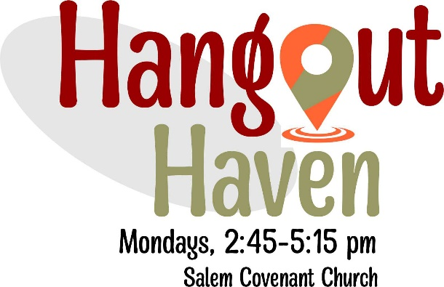

Emergency Contact Form
September 1, 2022 – August 31, 2023

Youth’s Name: _________________________________________________

Grade in School: _______________________________

Primary Contact: ________________________________ Phone number:______________

Secondary Contact: ______________________________ Phone number:______________

Allergies/Medical Information: __________________________________________________
_____________________________________________________________________________
_____________________________________________________________________________

Insurance Carrier: ______________________________________________________
Insurance ID Number: __________________________________________________
Name on Insurance card: ________________________________________________

Any tutorial instruction needed (circle): Yes No
If so, what subject: ____________________________

Other Important Information: _____________________________________________
______________________________________________________________________

How will student be transported to Hangout Haven? (ie, school bus, parent, friends) _________________________

Please circle Yes or No below:
Does Salem have permission to photograph your child (circle) ? Yes No
If yes, can your teen’s photo (without name) be used on our church’s Social Media/Websites (circle)? Yes No

Parent/Guardian Signature: _________________________________ Date:______________
Parent/Guardian name in print ___________________________

